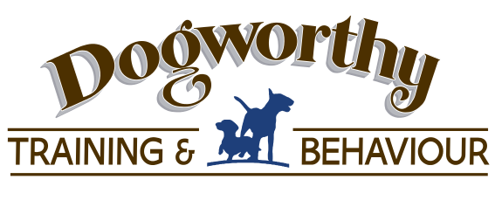
Class Welcome Pack

Here’s what you need to know before attending Dogworthy Classes…
Before Class:
- Treats - Bring with you lots of treats for your dog – you can bring their usual food, but also please bring some others of varying scrumptiousness. This will help you motivate them throughout the class. If in doubt, we do sell treats at 50p per bag.

- Toys – whatever your dog likes to play with, and a toy such a Kong stuffed with food to help occupy your dog when the humans are doing boring talking bits. Please leave squeaky ones at home though, this can be really distracting for some of your classmates!

- Collars/leads – generally we prefer our dog to wear a harness, choking and straining can cause real injuries, and whilst we strive to learn the perfect loose lead walk(!) it might be better to be safe than sorry. No choke/prong/noose/flexi-leads. Your lead should be long enough to touch the ground when slack, we can supply these if needed. NO FLEXI LEADS.
In Class:

- Arrivals – please try to arrive 10 mins early and have a mooch around outside the venue, this will decompress your dog from time in the car and get you and them nice and relaxed ready for fun and learning. If you are late, please don’t come straight in, leave the dog in the car and catch the trainer’s attention, enter when they say it is a good time.

- Meeting other dogs - Ideally all dogs are friendly all the time in class, however even I confess to having grouchy days. Classes should be fun and safe for all dogs, so there is a strict an on-lead policy at all times. Please only let your dog approach other dogs it knows and is comfortable with, and even then only for a two second meet and move. This will be covered in class but prevents obsessive staring etc and promotes good manners, ensuring concentration from all dogs during class.

- All the family are welcome in class, but remember ONE person has the treats, lead and dog at any one time, and that person must be over 16. If children are attending, please ensure they can sit quietly during the boring bits, and MUST be closely supervised – don’t let them approach any other dog, run around, or distract anyone else. Teach them to ask the owner of any dog if it is ok to pet the dog, and respect their answer. The same goes for adults too!

- Dogworthy uses only modern, science based methods so any harsh handling, shouting or scolding will be not be tolerated. It is very common for dogs to be unsuitable for class because they are stressed or unable to focus, in this case we will discuss screening, half timing and 121 training to help your dog if needs be.

- Leavings – there will be specified areas for dog toileting, please respect our facility and pick up after your dog, pretty coloured bags are available on request.

- Dogworthy sells treats, harnesses, toys, long lines and leads. Everything we stock is recommended by our trainers. Let us know if there is anything you would like to source, often we are cheaper than Pets at Home!
Dogworthy – Because Every Deserves His Day
Most importantly, please bring a sense of humour! We want both you and your dog to have fun and enjoy :)

